Linux Commands Assignment
SMIT – DEVOPS ENGINEER
Name: Muhammad Huzaifa Usman
Student ID: 914486
Section: Mon – Wed | 9:00 – 11:00
Course: DevOps Engineer
Submitted To: SMIT
Date: 20-10-2026

Question 1
Use the man command to explore the manual of find. Identify and explain the purpose of at least five options, then demonstrate any three of them with practical examples.
Commands & Output:
man find

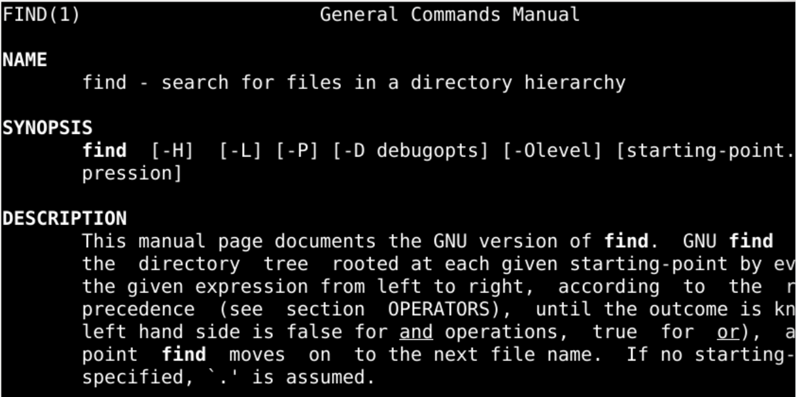

find ~ -name "*.txt" 2>/dev/null
find ~ -type d 2>/dev/null
find ~ -size +1M 2>/dev/null

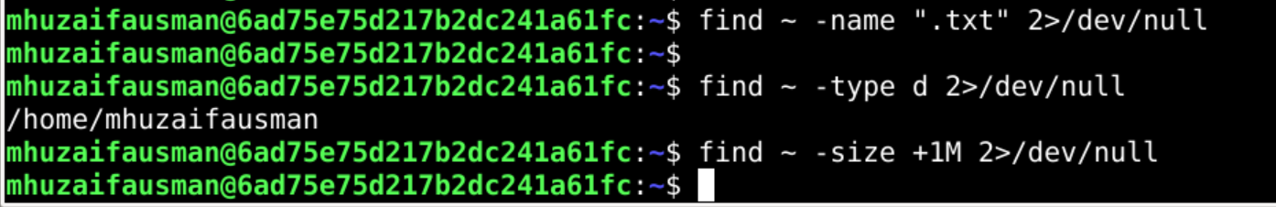

Explanation:
Options of find explained:
-name pattern: searches for files whose name matches the given pattern (case-sensitive), e.g. "*.txt".
-type f/d: restricts results to a file type; f = regular files, d = directories.
-size +1M: matches files by size; +1M means larger than 1 megabyte, -1M means smaller.
-mtime -n: matches files modified less than n days ago (e.g. -mtime -1 = last 24 hours).
-exec command {} \; : runs a command on every file that is found (for example, ls -l or rm).
Demonstrated: -name finds all .txt files, -type d lists only directories, and -size +1M lists files bigger than 1 MB. The 2>/dev/null part hides “Permission denied” error messages.

Question 2
Create a directory structure containing multiple subdirectories and files. Use mv to move a file into another directory, rename a file, and move multiple files using a single command. Show the results of each operation.
Commands & Output:
mkdir -p ~/lab/docs ~/lab/backup ~/lab/archive
touch ~/lab/docs/a.txt ~/lab/docs/b.txt ~/lab/docs/c.txt ~/lab/docs/notes.txt
ls -R ~/lab

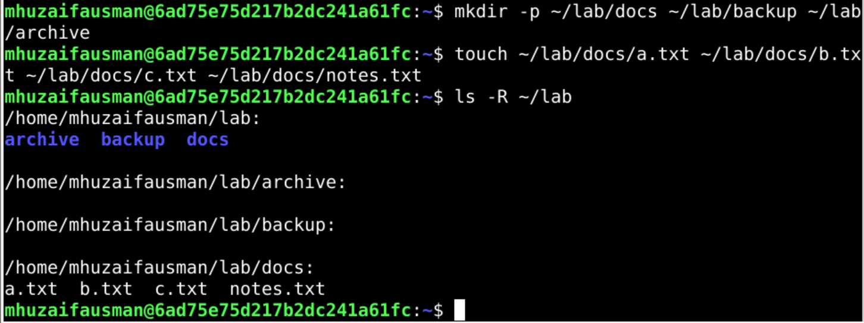

mv ~/lab/docs/a.txt ~/lab/backup/
ls -R ~/lab

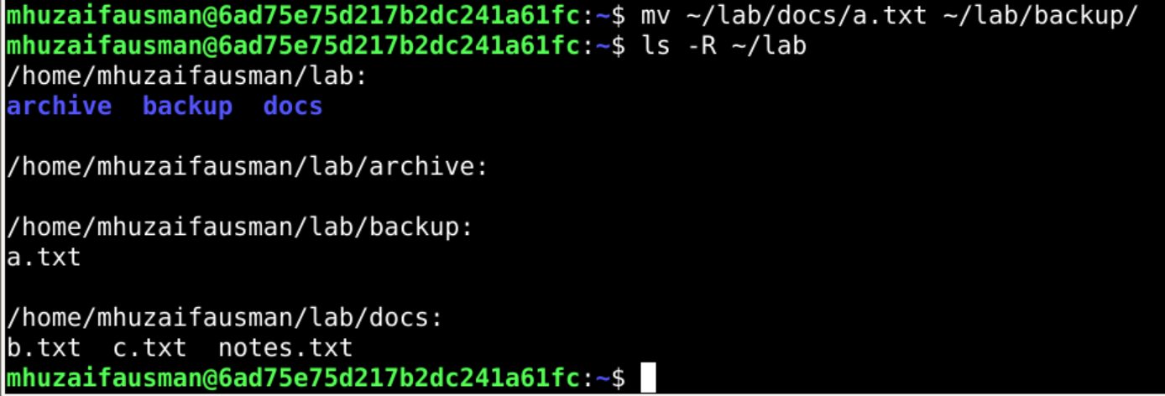

mv ~/lab/docs/b.txt ~/lab/docs/report.txt
ls ~/lab/docs

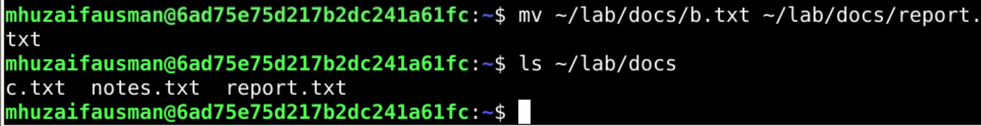

mv ~/lab/docs/c.txt ~/lab/docs/notes.txt ~/lab/archive/
ls -R ~/lab

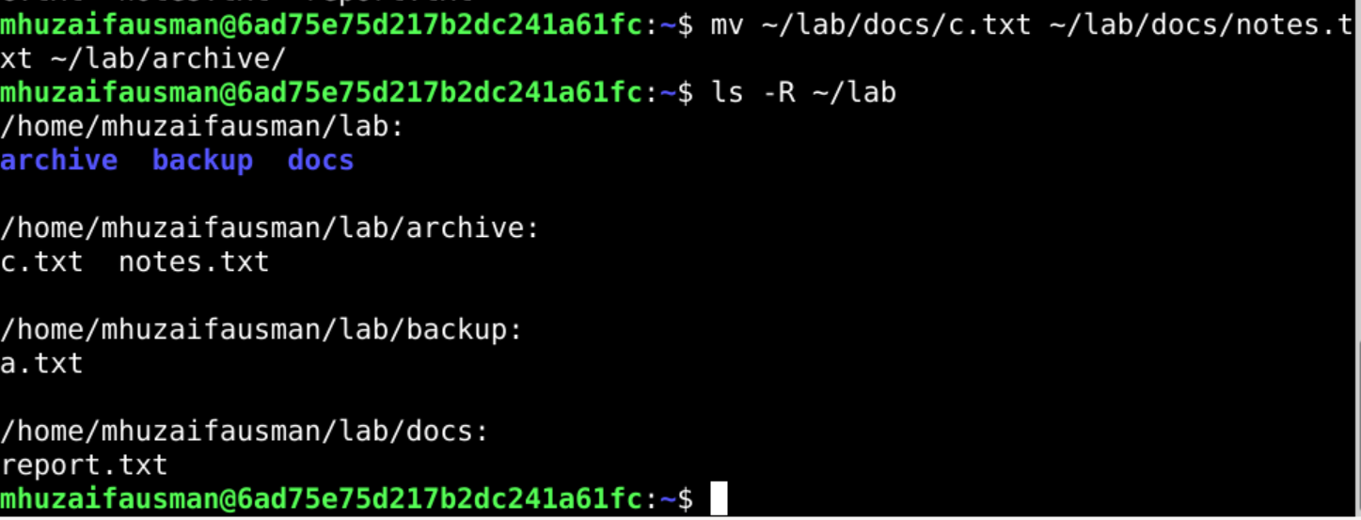

Explanation:
mv is used for both moving and renaming. Moving a file to a different directory changes its location, while giving a new name in the same directory renames it. When several source files are given, the last argument must be an existing destination directory.

Question 3
Use the history command to display your command history. Find a previously executed command and rerun it using its history number. Explain how you identified the command.
Commands & Output:
history
history | grep mkdir

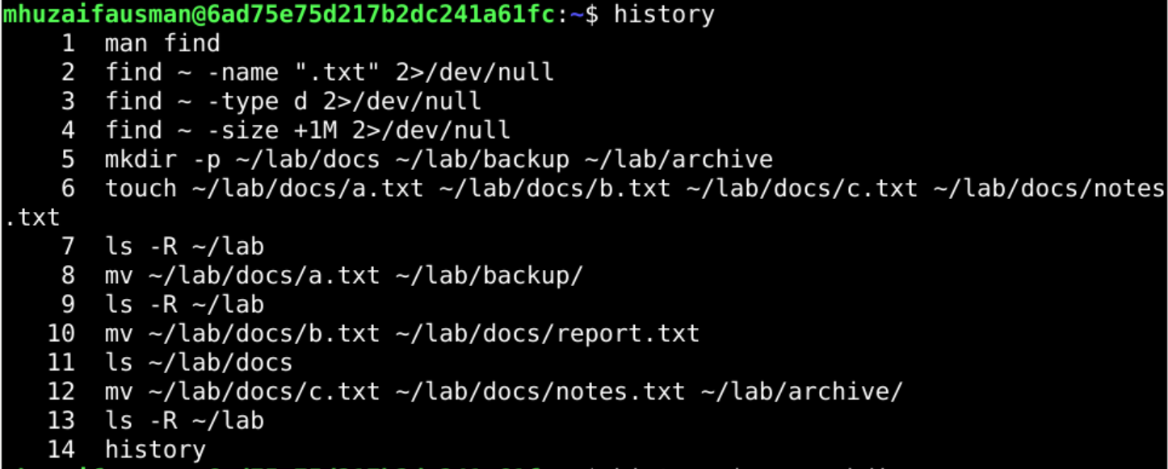

!<number> # replace <number> with the history number shown, e.g. !25

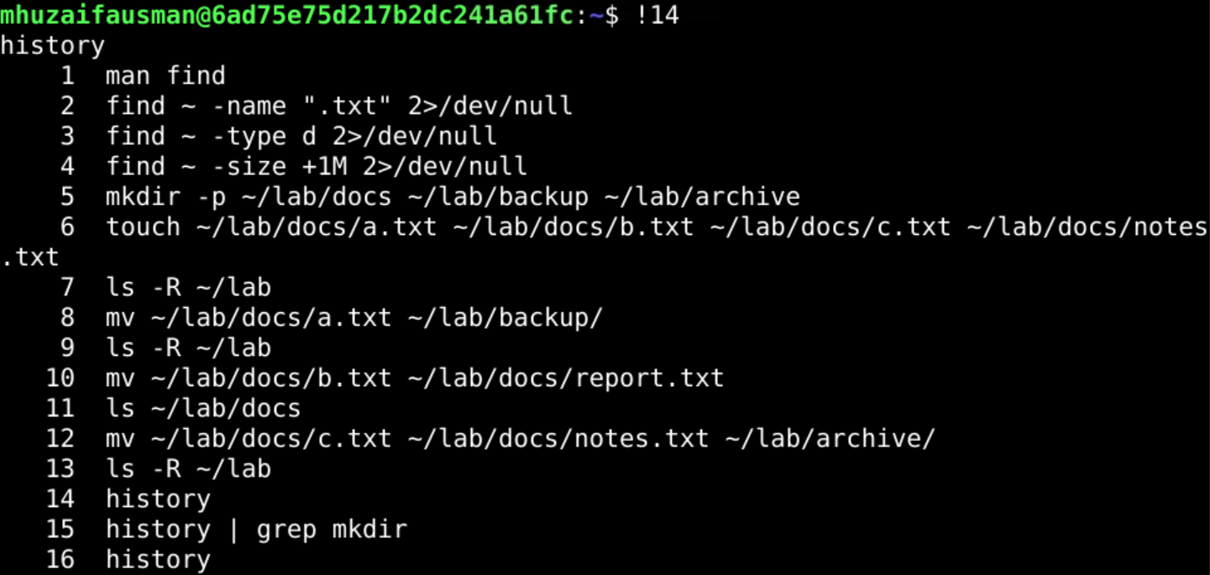

Explanation:
I ran history to list all previous commands with their numbers. To find a specific command quickly I filtered the list with history | grep mkdir, which showed only the lines containing “mkdir” along with their history numbers. I then re-executed it with !<number>, and the shell printed and ran that exact command again.

Question 4
Use the locate command to search for a file by name. If the search does not return the expected result, investigate whether the locate database needs updating. Show the commands and outputs. (If locate or updatedb is unavailable, mention this in your submission.)
Commands & Output:
sudo apt install plocate # only if locate is not installed
touch ~/lab/unique_file_xyz.txt
locate unique_file_xyz.txt

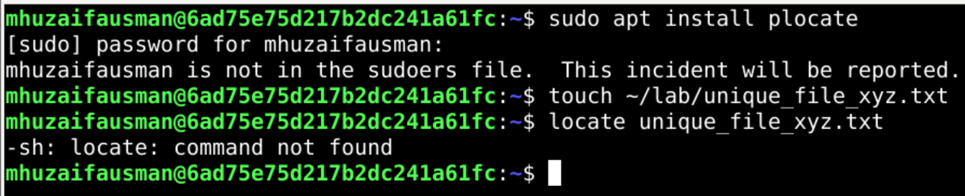

sudo updatedb
locate unique_file_xyz.txt

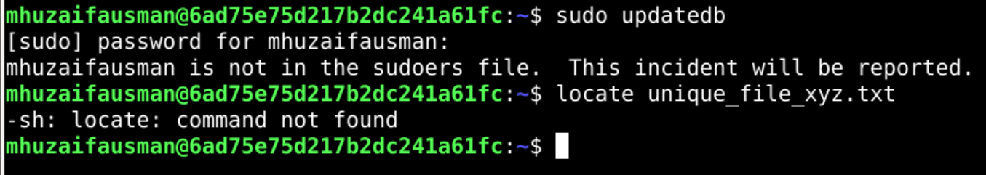

Explanation:
locate does not search the disk live; it searches a prebuilt database that is normally refreshed once a day. A file created just now is therefore not found until the database is updated. Running sudo updatedb rebuilds the database, after which locate finds the new file. (If locate/updatedb are not installed on the system, mention it here and install plocate or mlocate.)

Question 5
Use the find command to search for all .log files inside your home directory. Then find files modified within the last 24 hours and files larger than 1 MB. Share the commands and outputs.
Commands & Output:
find ~ -name "*.log" 2>/dev/null

find ~ -type f -mtime -1 2>/dev/null

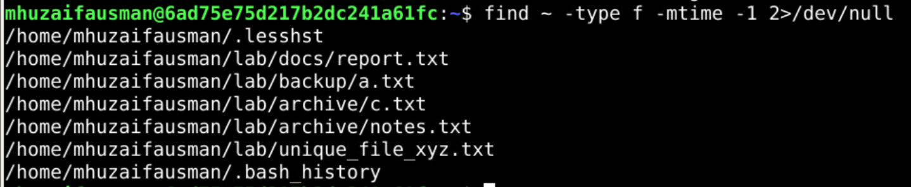

find ~ -type f -size +1M 2>/dev/null

Explanation:
-name "*.log" matches files ending with .log, -mtime -1 matches files modified less than one day (24 hours) ago, and -size +1M matches files larger than 1 MB. -type f limits the search to regular files.

Question 6
Use the help command to display the help information for three Bash built-in commands. Compare the output with the information provided by the man command for one of those commands.
Commands & Output:
help cd
help pwd
help echo

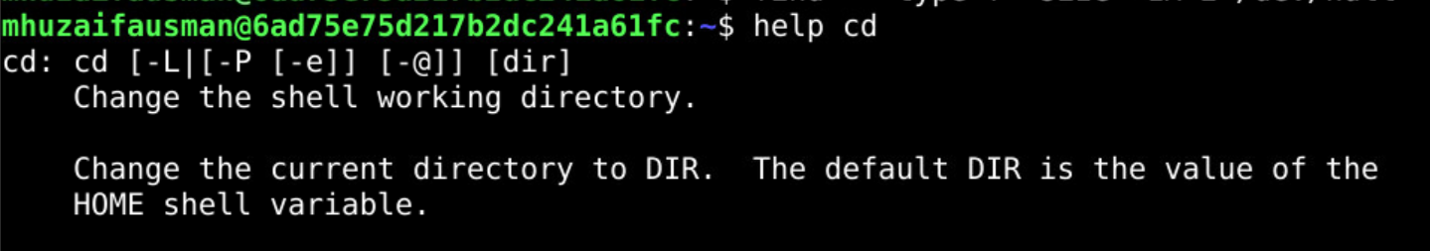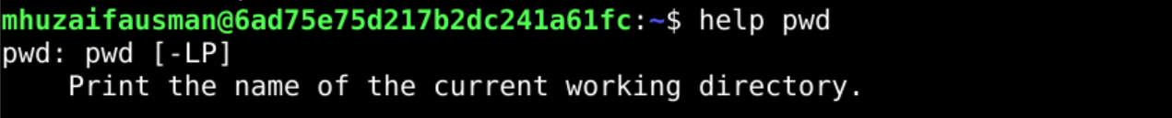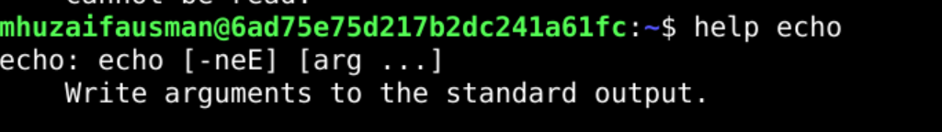

man cd
# if no separate page opens, use: man bash (then search /cd)

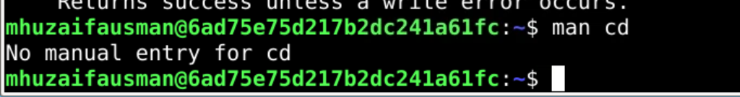

Explanation:
help displays a short, Bash-specific summary of a built-in: its syntax, options and a brief description, directly in the terminal. man shows a longer reference manual; for built-ins like cd it usually opens the general “BASH BUILTIN COMMANDS” section (or says there is no separate page), because built-ins are part of the shell itself and not separate programs. Therefore help is quicker for built-ins, while man is more detailed and complete.

Question 7
Use the which, type, and whatis commands to investigate ls, cd, sudo, and find. Record their outputs and explain the differences between command location, command type, and short command descriptions.
Commands & Output:
which ls cd sudo find

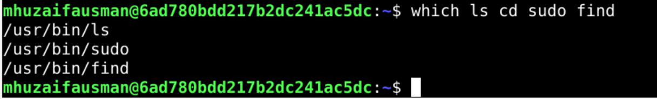

type ls cd sudo find

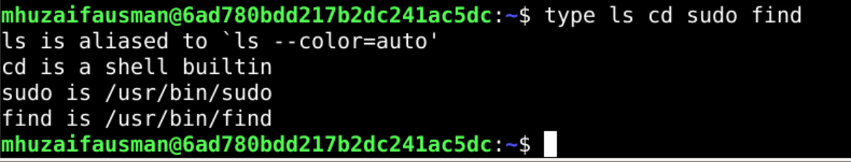

whatis ls cd sudo find

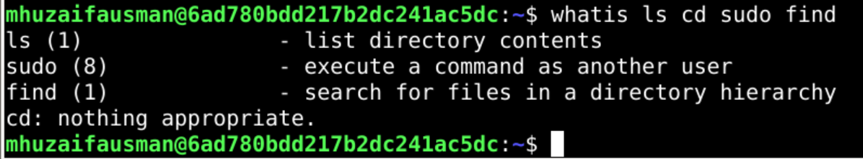

Explanation:
which shows the location (path) of the executable that would run, searching the directories in PATH (e.g. /usr/bin/find). Built-ins such as cd have no file, so which shows nothing for them.
type tells how the shell interprets a name: alias, shell built-in, function or an external file. For example, cd is a shell builtin, while sudo and find are files; ls is often an alias on many systems.
whatis prints a one-line description of the command taken from its manual page (e.g. “find - search for files in a directory hierarchy”).

Question 8
Use df -h to identify the filesystem with the most available space. Then use du -sh to check the size of your home directory and du -h --max-depth=1 ~ to compare the sizes of its immediate subdirectories. Explain the difference between the results.
Commands & Output:
df -h

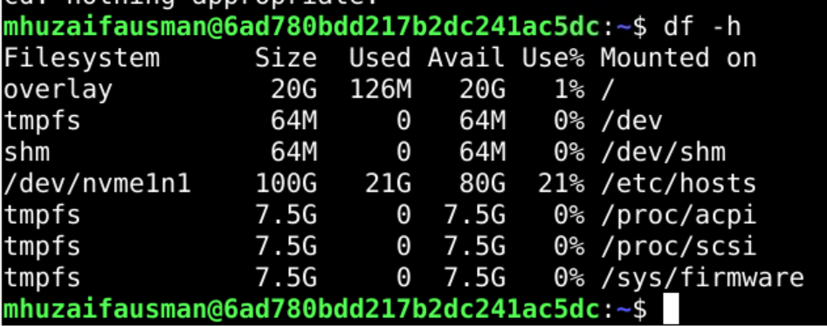

du -sh ~

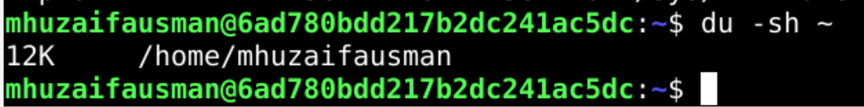

du -h --max-depth=1 ~

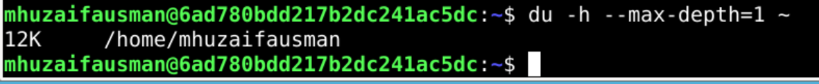

Explanation:
Filesystem with the most available space: ______________ (write it from your df -h output).
df -h reports usage of whole filesystems/partitions (size, used, available), taken from the filesystem’s own information. du reports how much space files and directories actually occupy. du -sh ~ gives a single summarized total for the home directory, while du -h --max-depth=1 ~ breaks that total down per immediate subdirectory, so the individual sizes add up to (about) the total. Totals of df and du differ because df covers the entire partition (system files, other users, reserved space), whereas du only counts the directory it is pointed at.

Question 9
Use sudo to perform an administrative task, such as creating a directory under /opt named linux_assignment. Verify that it was created. Then explain why administrative privileges are required for this task.
Commands & Output:
sudo mkdir /opt/linux_assignment
ls -ld /opt/linux_assignment
ls -l /opt

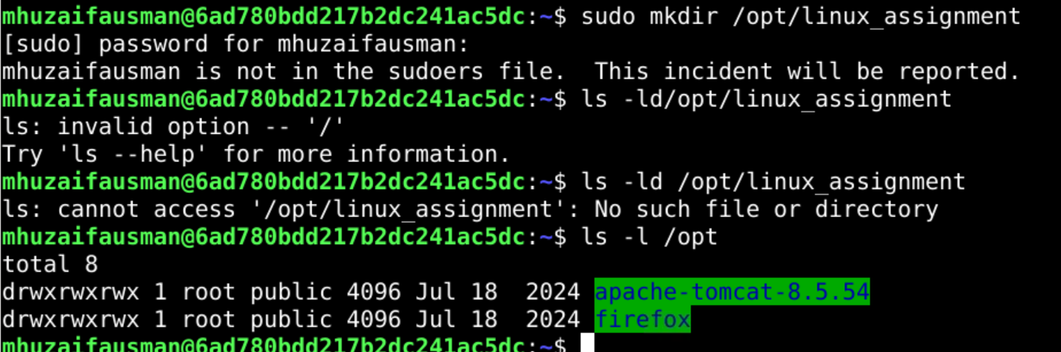

Explanation:
/opt is a system directory owned by root, and ordinary users do not have write permission in it. Without sudo, mkdir would fail with “Permission denied”. sudo runs the command with administrator (root) privileges, so the directory can be created. The verification shows the new directory owned by root.

Question 10
Create two text files named original.txt and updated.txt with similar but slightly different content. Use the diff command to compare them. Then demonstrate the difference between normal output and unified output using diff -u.
Commands & Output:
printf "Linux is an open source operating system.\nIt is widely used on servers.\nStudents learn commands in labs.\n" > original.txt
printf "Linux is a free and open source operating system.\nIt is widely used on servers.\nStudents practice commands in labs.\nThey also learn shell scripting.\n" > updated.txt
cat original.txt
cat updated.txt

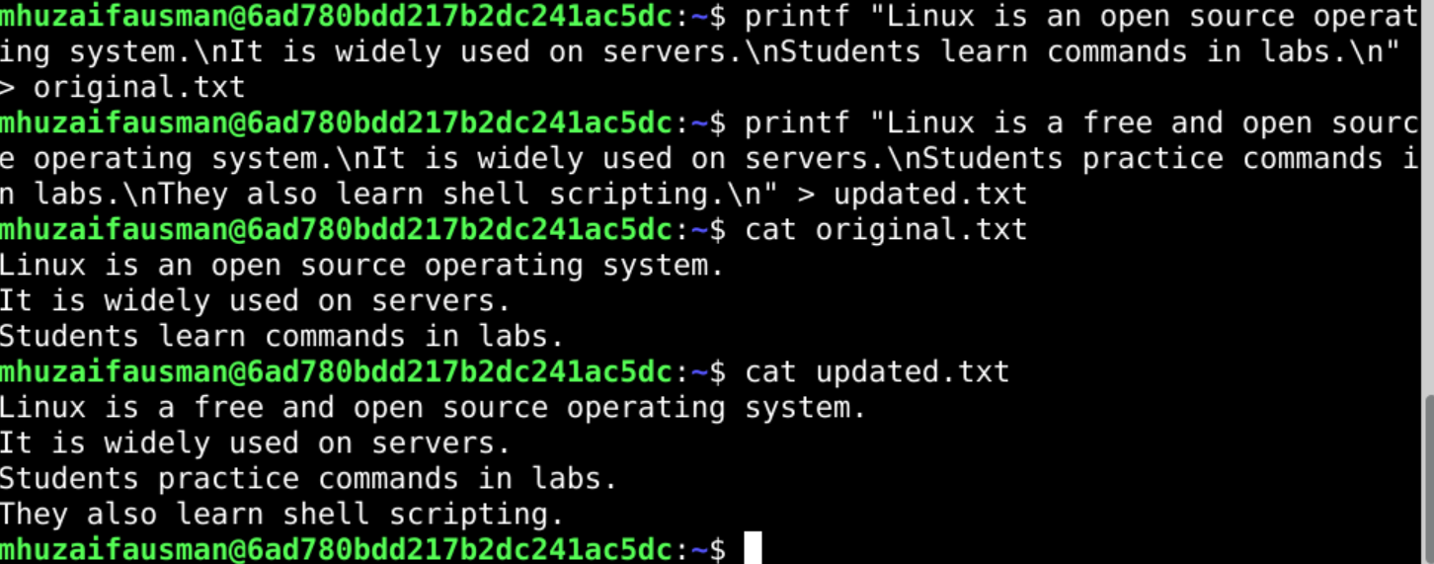

diff original.txt updated.txt

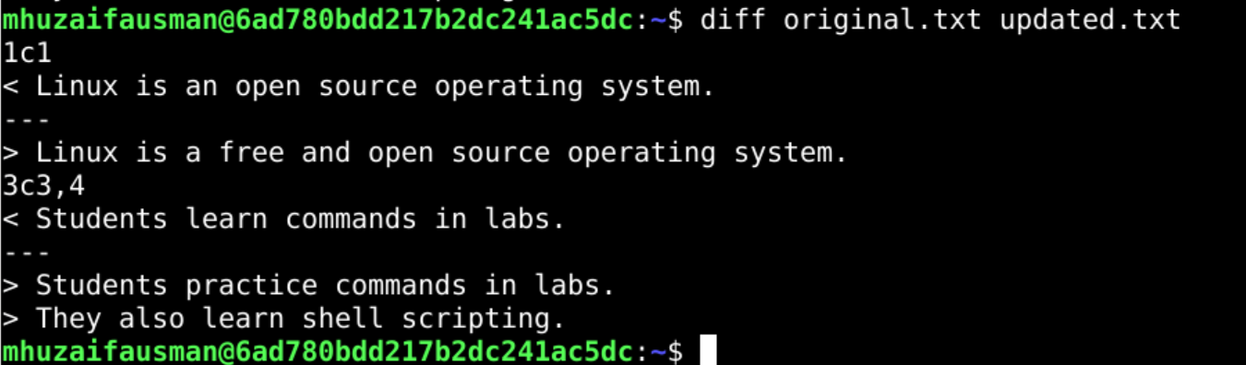

diff -u original.txt updated.txt

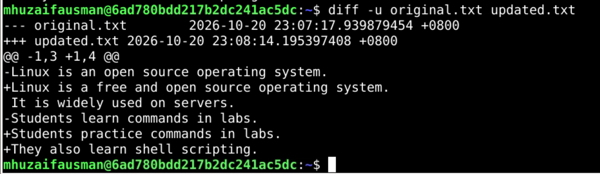

Explanation:
Normal diff output shows only the differing lines, with change instructions such as 1c1 (line changed), 3a4 (line added); lines starting with < come from the first file and lines starting with > from the second.
Unified output (diff -u) shows file names with --- and +++, a hunk header like @@ -1,3 +1,4 @@, and also some unchanged context lines. Lines starting with - were removed/changed from the original and lines starting with + were added in the updated file. It is easier to read and is the format used by patches.

Question 11
Create a file named permissions.txt. Use chmod with both symbolic and numeric modes to set its permissions to rw-r-----. Verify the final permissions using ls -l and explain what the permissions mean for the owner, group, and others.
Commands & Output:
touch permissions.txt
ls -l permissions.txt

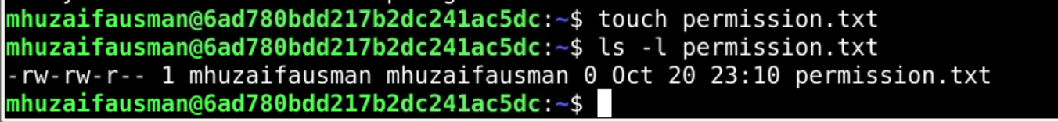

chmod u=rw,g=r,o= permissions.txt
ls -l permissions.txt

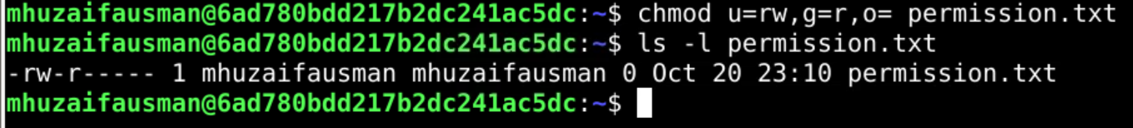

chmod 777 permissions.txt # reset first to show the change
chmod 640 permissions.txt
ls -l permissions.txt

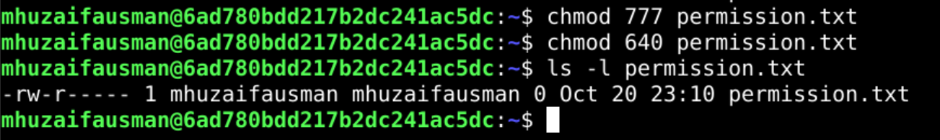

Explanation:
Final permissions: rw-r----- (numeric 640).
Owner (rw-): can read and write the file, but not execute it. Group (r--): can only read the file. Others (---): have no access at all.
Numeric calculation: read = 4, write = 2, execute = 1. Owner 4+2 = 6, group 4 = 4, others 0 = 0, so 640.

Question 12
Create a directory named team_project and a file inside it. Use chmod to assign appropriate permissions to the directory and file so the owner has full access, the group can read the file, and others have no access. Verify and explain your settings.
Commands & Output:
mkdir team_project
touch team_project/project_notes.txt
chmod 750 team_project
chmod 640 team_project/project_notes.txt
ls -ld team_project
ls -l team_project

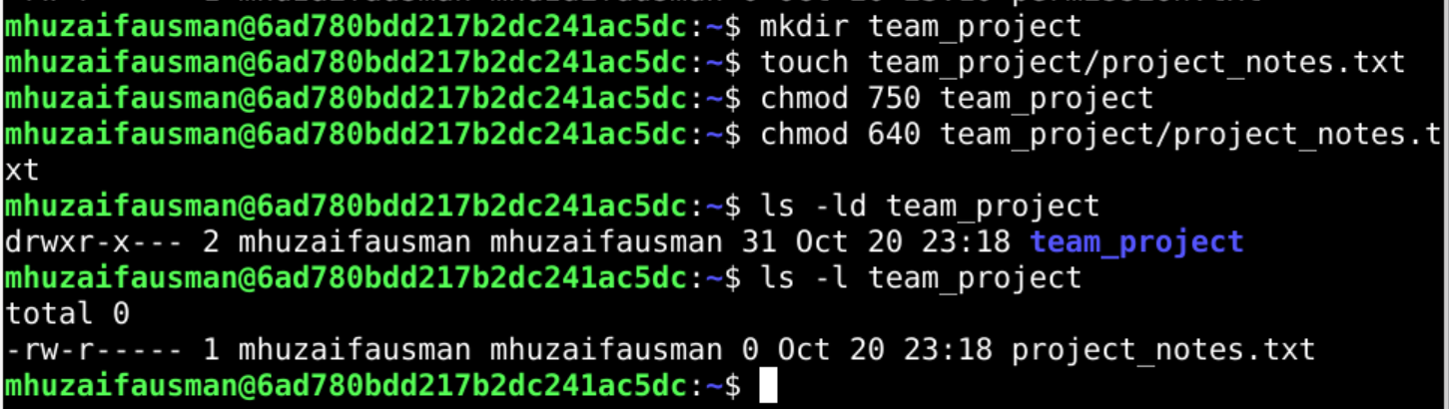

Explanation:
Directory team_project = 750 (rwxr-x---): the owner has full access; the group can enter (x) and list (r) the directory; others have no access.
File project_notes.txt = 640 (rw-r-----): the owner can read and write; the group can only read; others have no access.
The group needs execute (x) on the directory; otherwise it could not enter the directory to read the file inside.

Question 13
Use sudo chown to change the ownership of a test file to another existing user on your system. Verify the change using ls -l. If another user is unavailable, explain the prerequisite rather than changing ownership of an important system file.
Commands & Output:
cut -d: -f1 /etc/passwd | tail
touch test_owner.txt
ls -l test_owner.txt

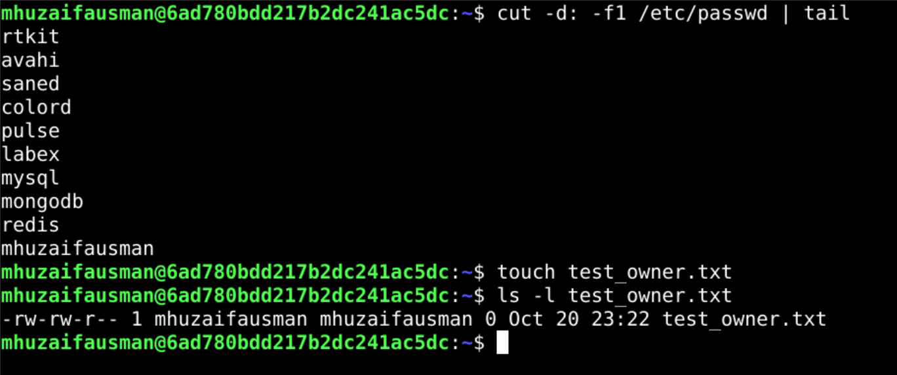

sudo chown <username> test_owner.txt # replace <username> with an existing user
ls -l test_owner.txt

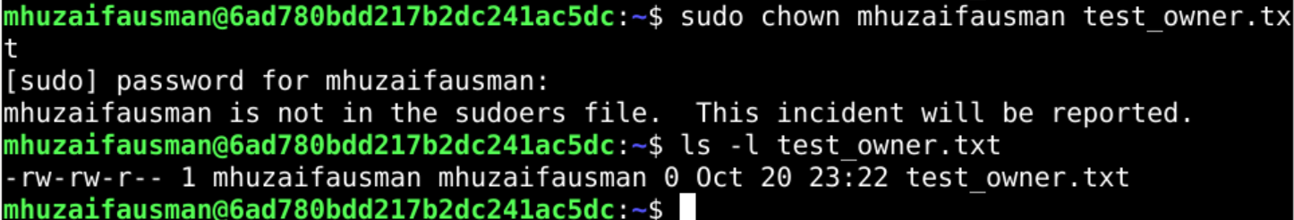

Explanation:
chown changes the owner of a file. Only root can give a file to another user, which is why sudo is required. The prerequisite is that the target user must already exist on the system (it can be created with sudo adduser <name>). I used only my own test file and did not change ownership of any system file.

Question 14
Create a directory containing at least five files with different extensions, such as .txt, .log, and .conf. Use find with appropriate conditions to locate files matching two criteria, such as files larger than a specified size and files modified within the last seven days. Display the results and explain your search conditions.
Commands & Output:
mkdir ~/find_lab && cd ~/find_lab
touch notes.txt app.conf data.csv script.sh
dd if=/dev/zero of=server.log bs=1M count=2
dd if=/dev/zero of=old_backup.log bs=1M count=2
touch -d "10 days ago" old_backup.log
ls -l

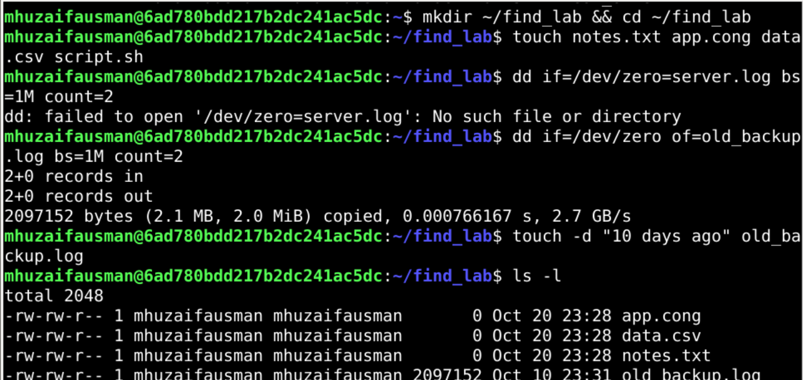

find ~/find_lab -type f -size +1M -mtime -7 -ls

Explanation:
-type f: only regular files. -size +1M: larger than 1 MB. -mtime -7: modified within the last 7 days. When conditions are written together, find treats them as AND, so only files meeting both are shown. server.log (2 MB, new) matches, while old_backup.log is excluded because it was modified 10 days ago.

Question 15
Practical challenge: Create a directory named devops_lab containing logs, reports, and scripts subdirectories. Create sample files, move the log files into logs, compare two report files using diff, locate all .log files using find, check the directory's disk usage using du, and configure suitable permissions using chmod and chown. Use sudo only when necessary. Submit screenshots showing the commands and their outputs at each stage.
Commands & Output:
mkdir -p ~/devops_lab/logs ~/devops_lab/reports ~/devops_lab/scripts
cd ~/devops_lab
touch app.log error.log access.log
printf "Sales: 100\nUsers: 50\n" > reports/report_jan.txt
printf "Sales: 120\nUsers: 65\n" > reports/report_feb.txt
printf "#!/bin/bash\necho Backup started\n" > scripts/backup.sh
ls -R

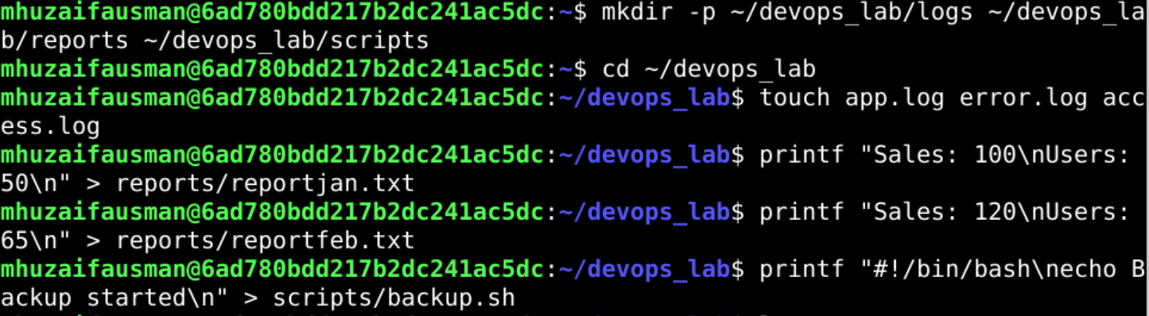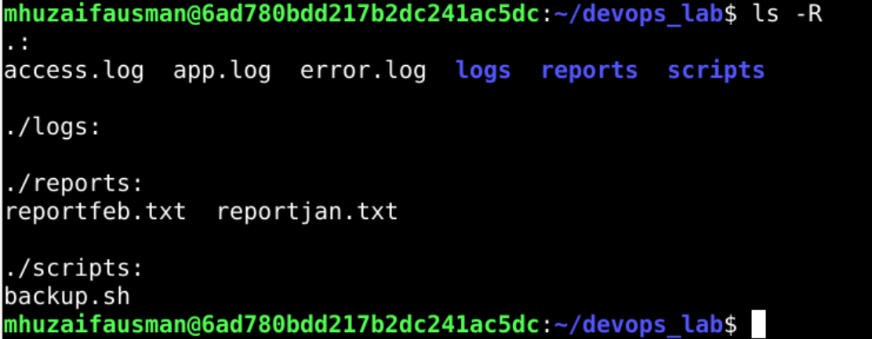

mv *.log logs/
ls -R

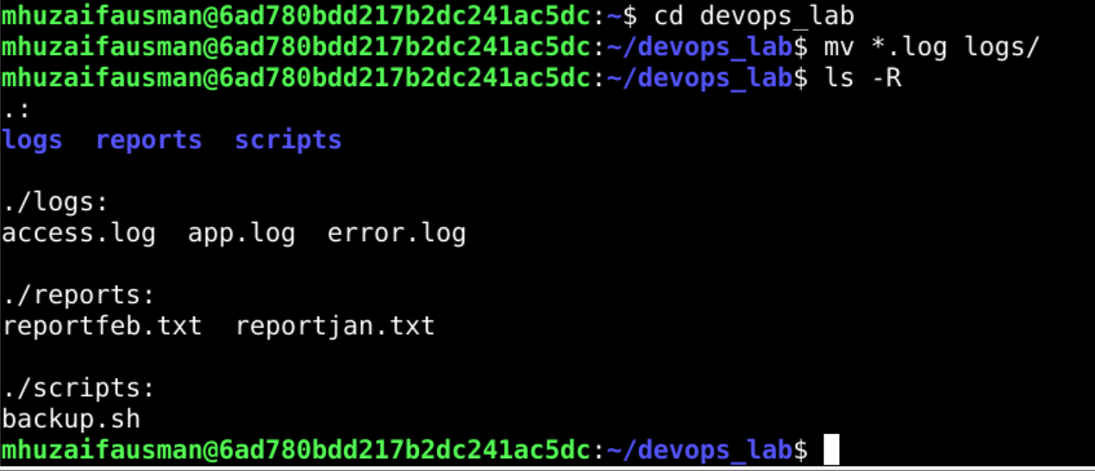

diff reports/report_jan.txt reports/report_feb.txt

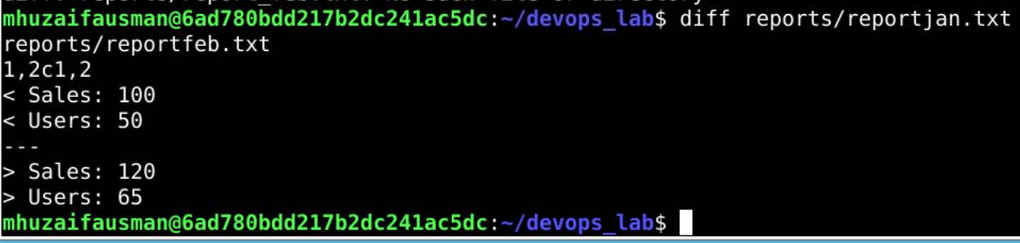

find ~/devops_lab -name "*.log"

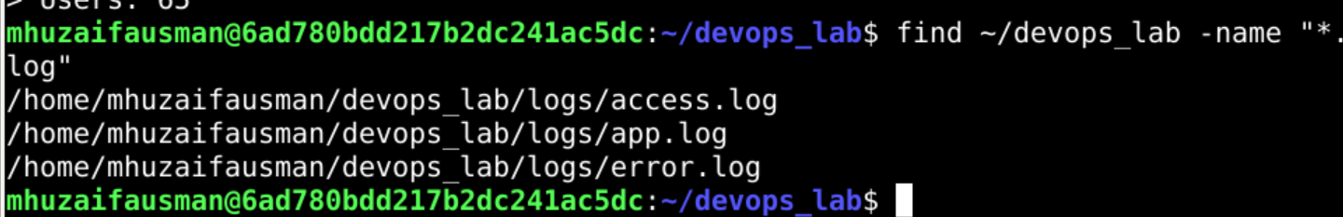

du -sh ~/devops_lab
du -h ~/devops_lab

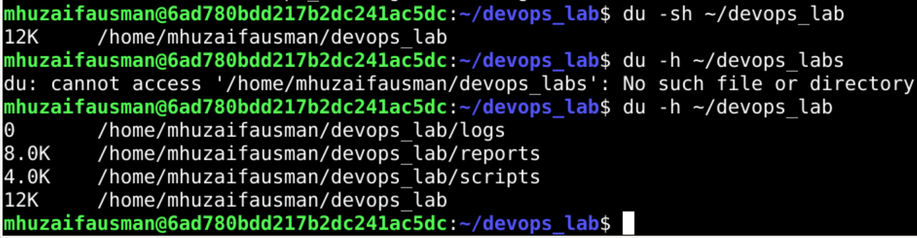

chmod 750 scripts/backup.sh
chmod 640 logs/*.log reports/*.txt
chmod 750 ~/devops_lab
sudo chown -R $USER:$USER ~/devops_lab
ls -lR ~/devops_lab

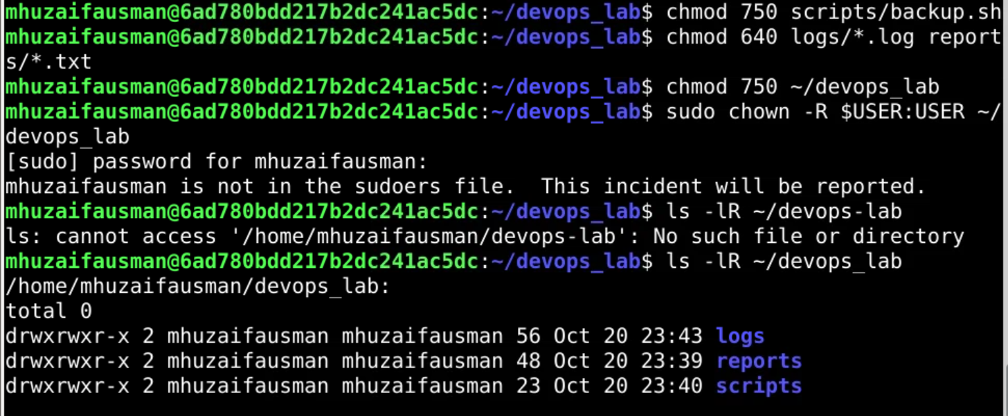

Explanation:
Explanation: logs, reports and scripts were created with mkdir -p; mv *.log logs/ moved all log files in one command; diff showed the differences between the two reports; find located every .log file (now inside logs); du -sh gave the total size of devops_lab. The script got 750 (owner can execute it, group can read/execute), data files got 640, and the directory 750 so others have no access. sudo was used only for chown, which needs administrator rights when changing ownership; since the files already belong to me, it makes no actual change here.

